* Sign-up:

|  |  |  |
| --- | --- | --- |
| **Test Case ID** | **Description** | **Screenshots** |
| Sign-up 01 | VIP user creates an account successfully. | added |
| Sign-up 02 | VIP user uses an already existing email. | added |
| Sign-up 03 | VIP user leaves required fields empty | added |

* Sign-in:

|  |  |  |
| --- | --- | --- |
| **Test Case ID** | **Description** | **Screenshots** |
| Sign-in 01 | VIP user signs in successfully. | added |
| Sign-in 02 | VIP user uses a wrong email address and/or password. | added |

* Reserve Parking:

|  |  |  |
| --- | --- | --- |
| **Test Case ID** | **Description** | **Screenshots** |
| Reserve Parking 01 | VIP user reserves a parking spot successfully. | added |
| Reserve Parking 02 | VIP user already has a reservation at the selected time he/she wants to reserve on. | added |
| Reserve Parking 03 | VIP user tries to reserve at a time where there is no available parking spot. | added |
| Reserve Parking 04 | VIP user tries to reserve before the allowable reservation time which is same day or one day before. | added |
| Reserve Parking 05 | VIP user tries to reserve at a time that has elapsed. | added |
| Reserve Parking 06 | VIP user tries to reserve more than the number of allowable reservation hours per day (6 hours) | added |
| Reserve Parking 07 | VIP user is notified 30 minutes before reservation expiring time. | Not applicable |

* View Reservation:

|  |  |  |
| --- | --- | --- |
| **Test Case ID** | **Description** | **Screenshots** |
| View Reservation 01 | VIP user successfully views all his/her current and upcoming reservations. | added |

* Extend Reservation:

|  |  |  |
| --- | --- | --- |
| **Test Case ID** | **Description** | **Screenshots** |
| Extend Reservation 01 | VIP user successfully extends a reservation and the extension price is added to the reservation. |  |
| Extend Reservation 02 | VIP user tries to extend before the last hour of the reservation. | added |
| Extend Reservation 03 | VIP user tries to extend where there is no available parking spot after the reservation time. |  |

* Cancel Reservation:

|  |  |  |
| --- | --- | --- |
| **Test Case ID** | **Description** | **Screenshots** |
| Cancel Reservation 01 | VIP user successfully cancels the whole reservation and the deduction amount is calculated and deducted from the total price of the reservation, if the reservation *has not* started. | work |
| Cancel Reservation 02 | VIP user successfully cancels remaining reservation hours from now and the deduction amount is calculated and deducted from the total price of the reservation, If the reservation *has* started |  |

* View Parking:

|  |  |  |
| --- | --- | --- |
| **Test Case ID** | **Description** | **Screenshots** |
| View Parking 01 | User successfully views a map of the parking spots current status. | What? Current?  ?? |
| View Parking 02 | User successfully gets directions for a specific spot. | added |

* Request Car Care:

|  |  |  |
| --- | --- | --- |
| **Test Case ID** | **Description** | **Screenshots** |
| Request Car Care 01 | VIP user is successfully redirected to the Servesni application or website, if the application is installed in the phone | work |
| Request Car Care 02 | VIP user redirected to the Play store, if the application is not installed in the phone | Not applicable |

* View Current Occupancy Trend:

|  |  |  |
| --- | --- | --- |
| **Test Case ID** | **Description** | **Screenshots** |
| View Current Occupancy Trend 01 | User successfully views statistical data that represent occupied percentage in each hour for selected zone for last four weeks. |  |

* Check In

|  |  |  |
| --- | --- | --- |
| **Test Case ID** | **Description** | **Screenshots** |
| Check In 01 | VIP user successfully checks in to zone if he has reservation at the current time and zone. |  |
| Check In 02 | VIP user tries to check in to zone when he does not have a reservation at the current time. |  |
| Check In 03 | VIP user tries to check in to zone when his reservation is in another zone |  |
| Check In 04 | VIP user tries to check in to zone when he cancels his reservation. |  |

* Check Out

|  |  |  |
| --- | --- | --- |
| **Test Case ID** | **Description** | **Screenshots** |
| Check Out 01 | VIP user successfully checks out of zone *when/before* his reservation time has ended (without penalty) |  |
| Check Out 02 | VIP user checks out of zone *after* his reservation time has ended (with penalty) |  |
| Check Out 03 | VIP user cancels part of his reservation using application/website and checks out of zone *when/before* his reservation has ended (without penalty) |  |
| Check Out 04 | VIP user cancels part of his reservation using application/website and checks out of zone *after* his reservation has ended (with penalty) |  |
| Check Out 05 | VIP user checks out of zone *when/before* his extension time has ended (without penalty) |  |
| Check Out 06 | VIP user checks out of zone *after* his extension time has ended (with penalty) |  |
| Check Out 07 | VIP user checks out of zone and automatic cancellation is applied when his reservation time has an hour or more left. |  |

* Update Parking Availability

|  |  |  |
| --- | --- | --- |
| **Test Case ID** | **Description** | **Screenshots** |
| Update Parking Availability 01 | User successfully enters/leaves a parking spot and the availability status of the parking spot is updated. |  |

Singup-01

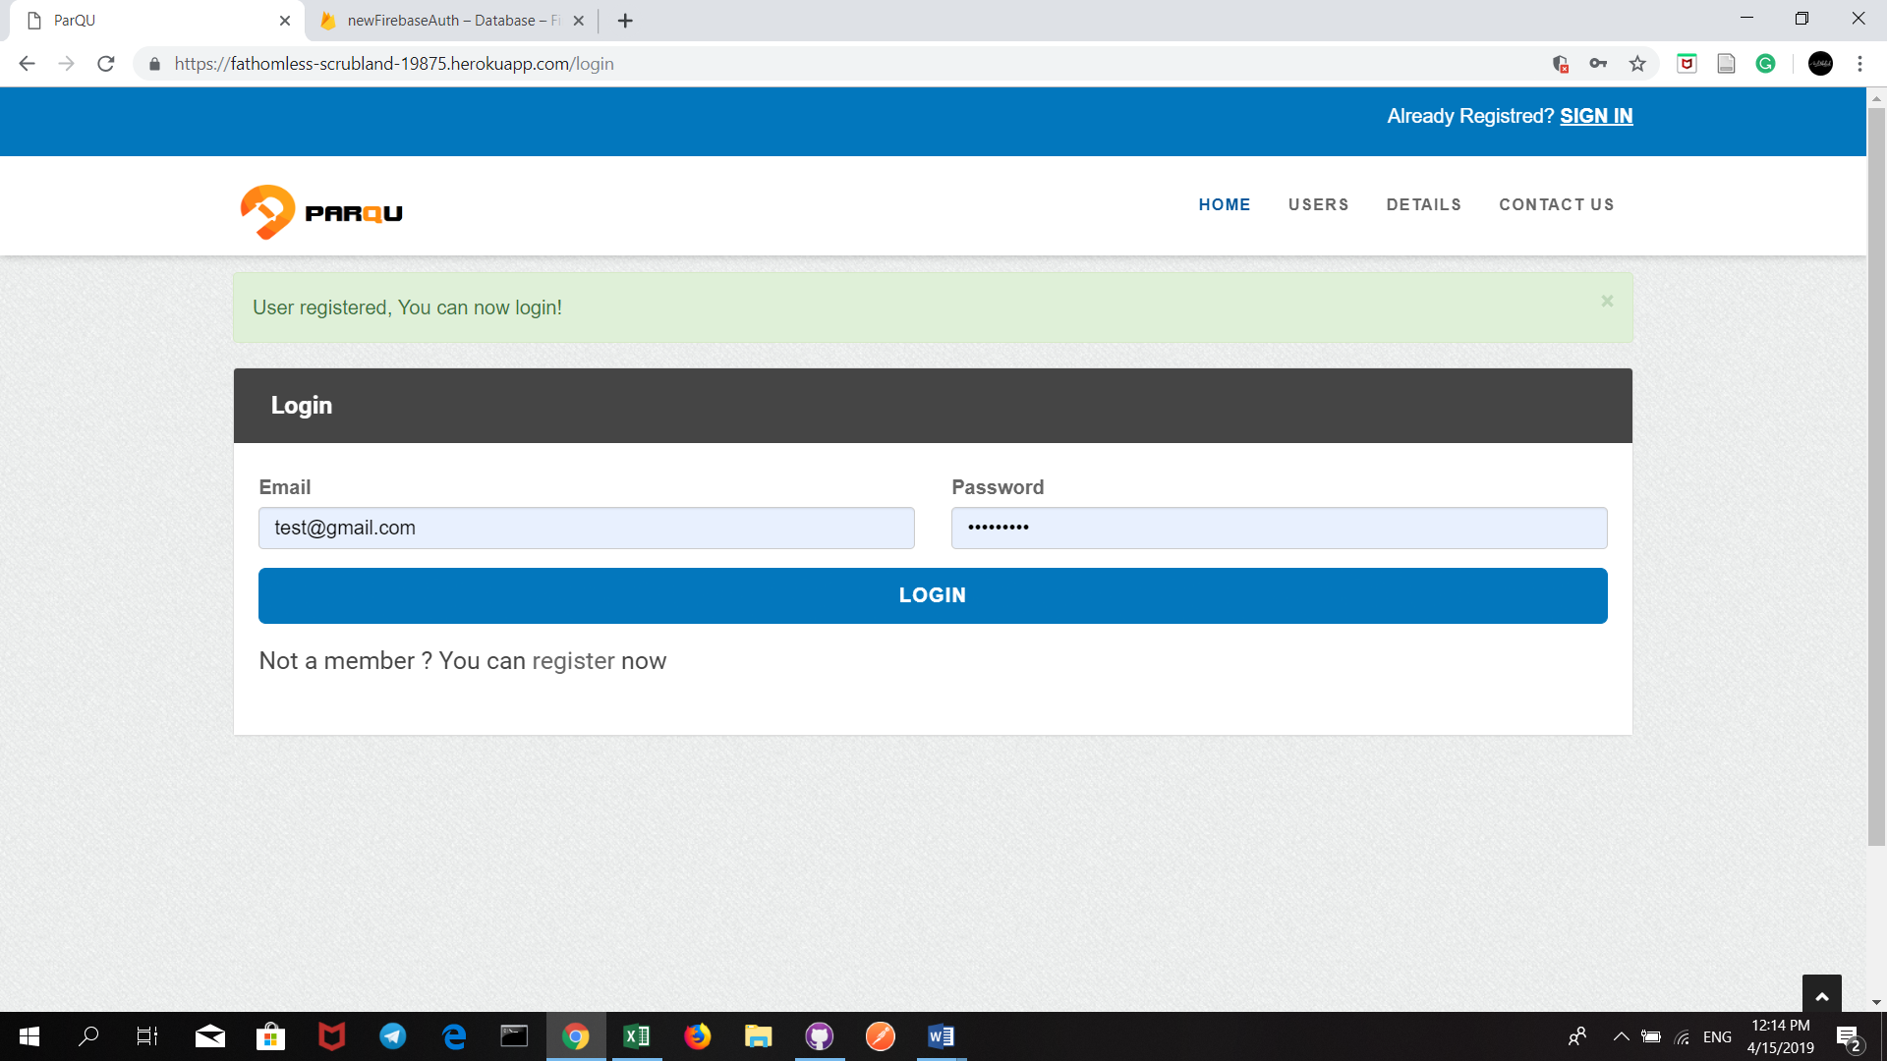

Signup-02

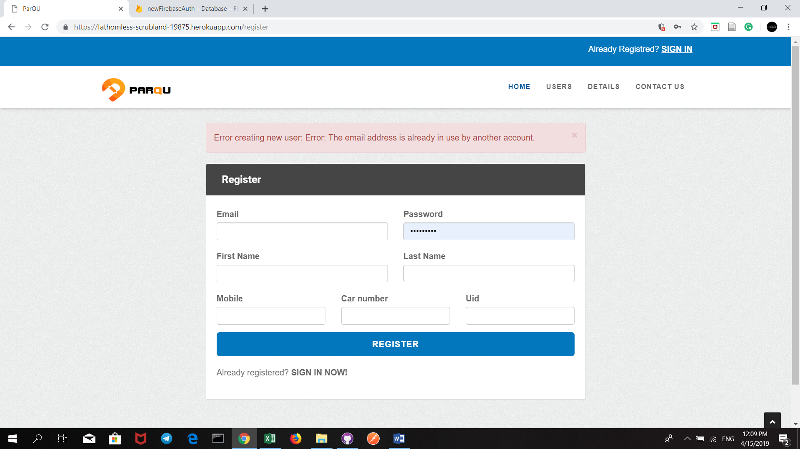

Signup-03

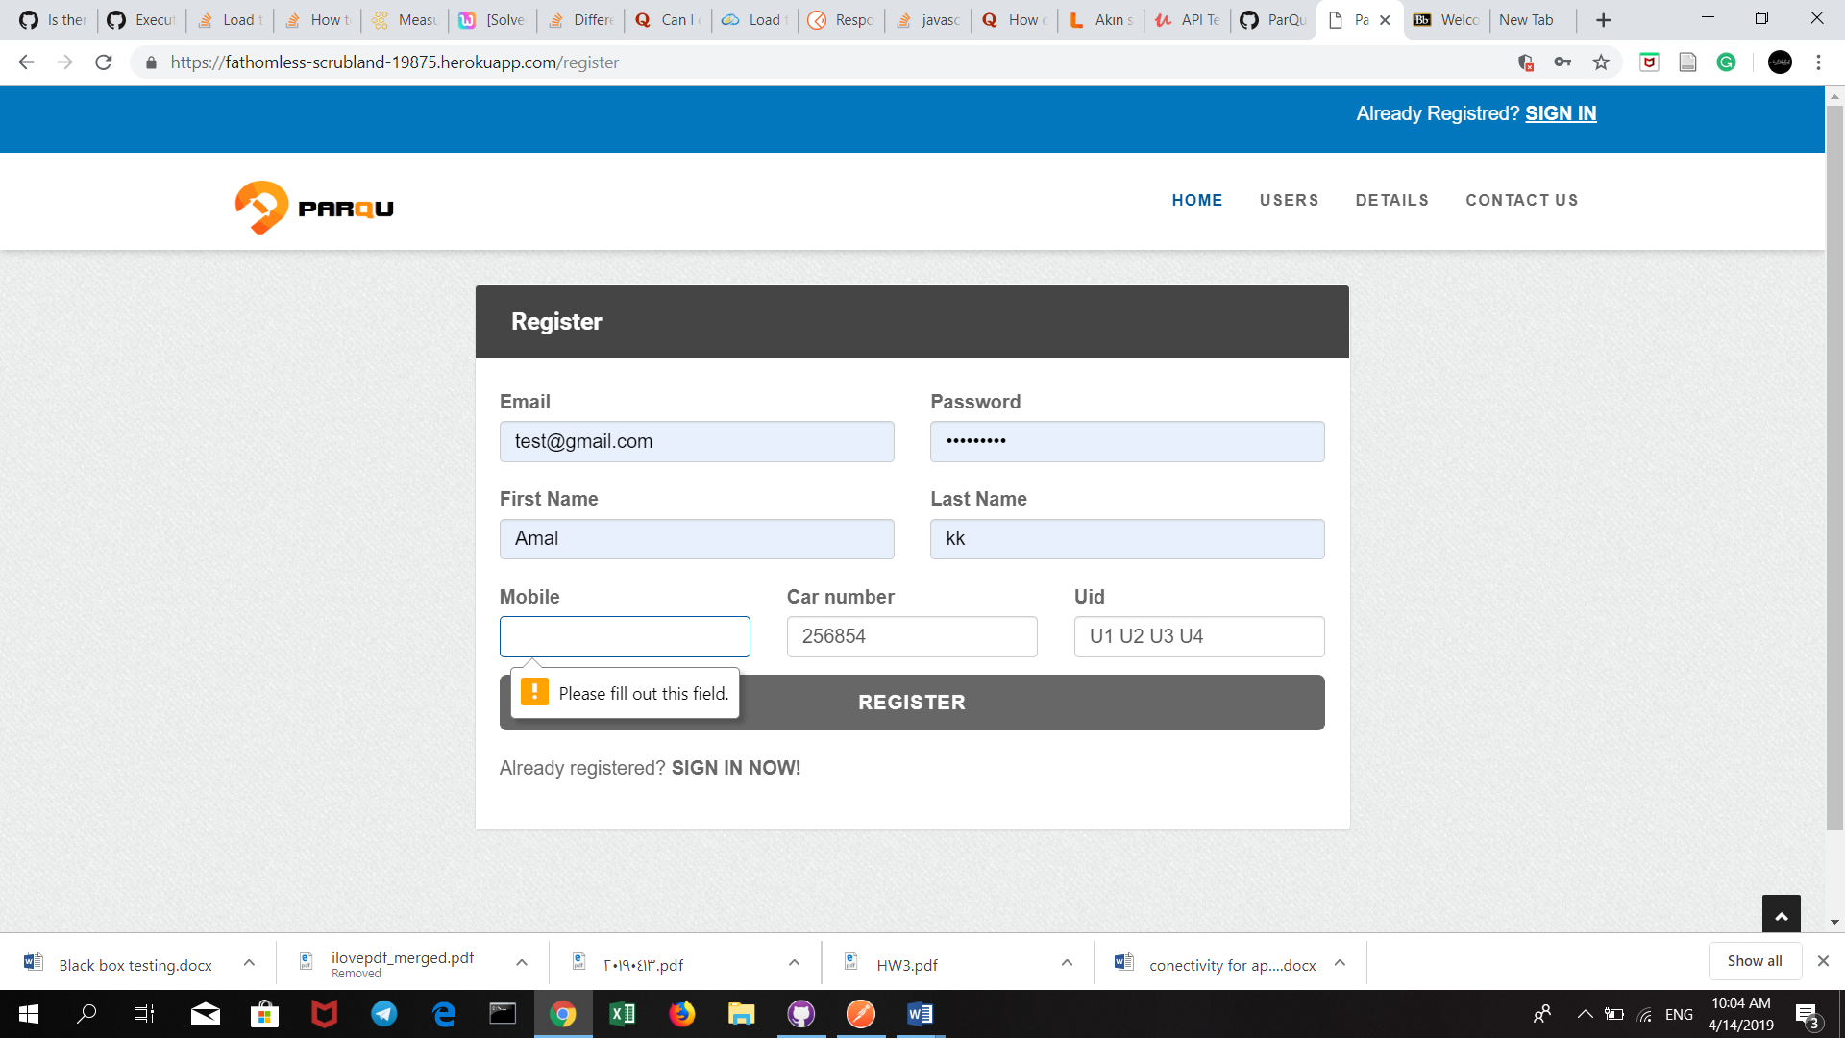

Sign-in 01

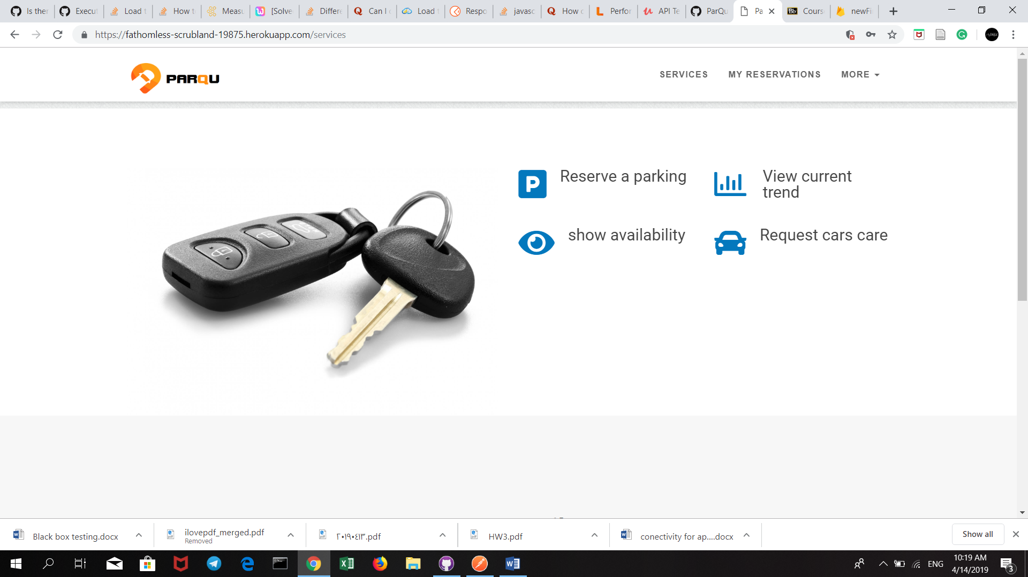

Sign-in 02

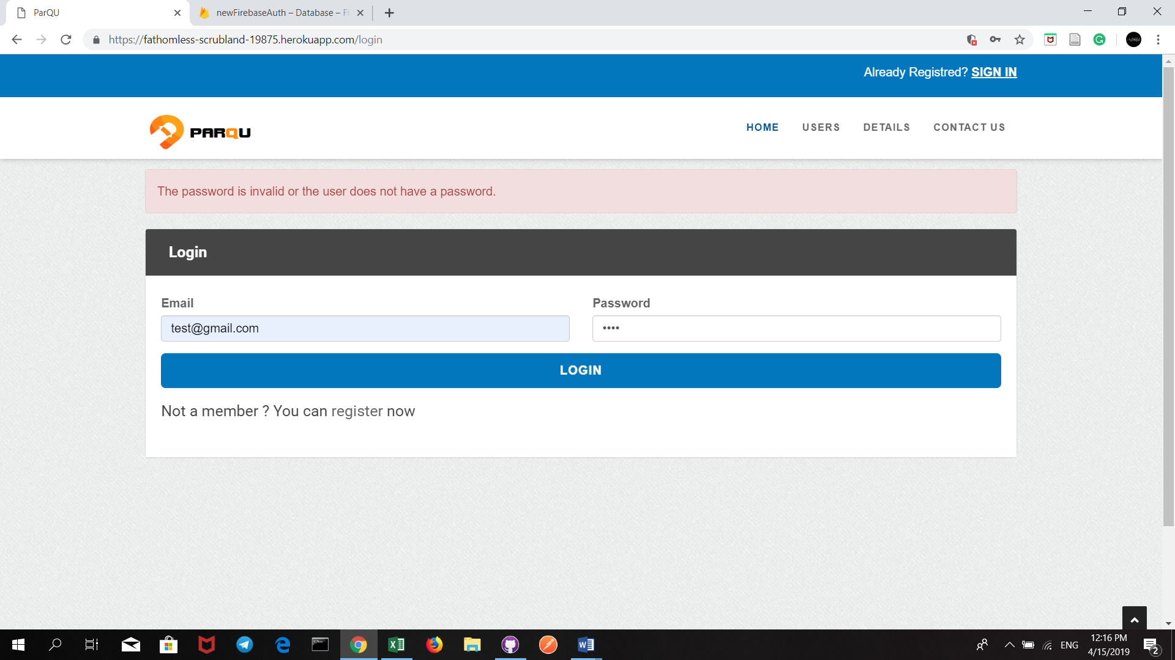

Reserve parking 01

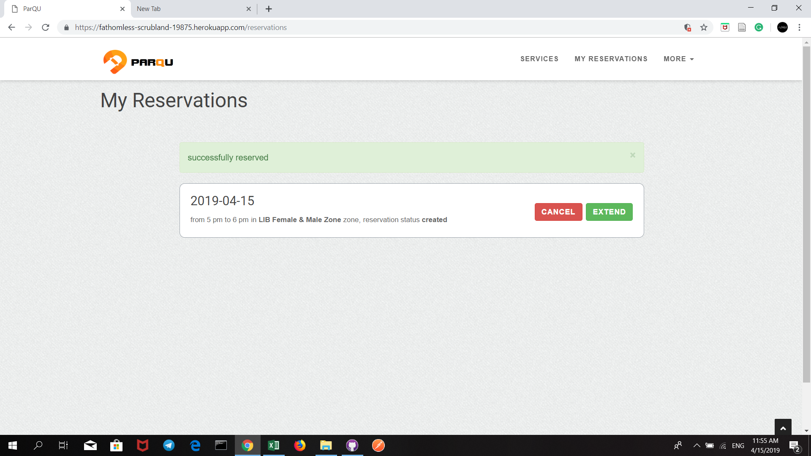

Reserve parking 02

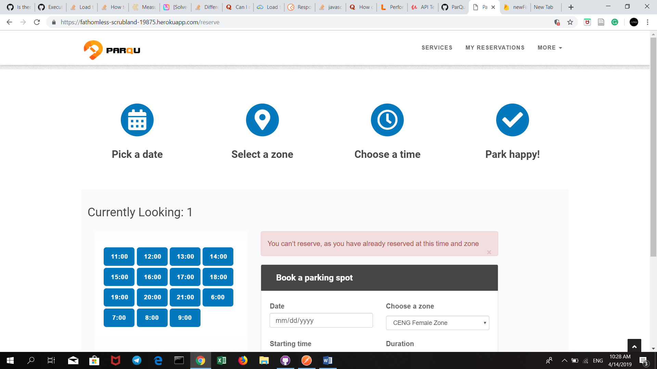

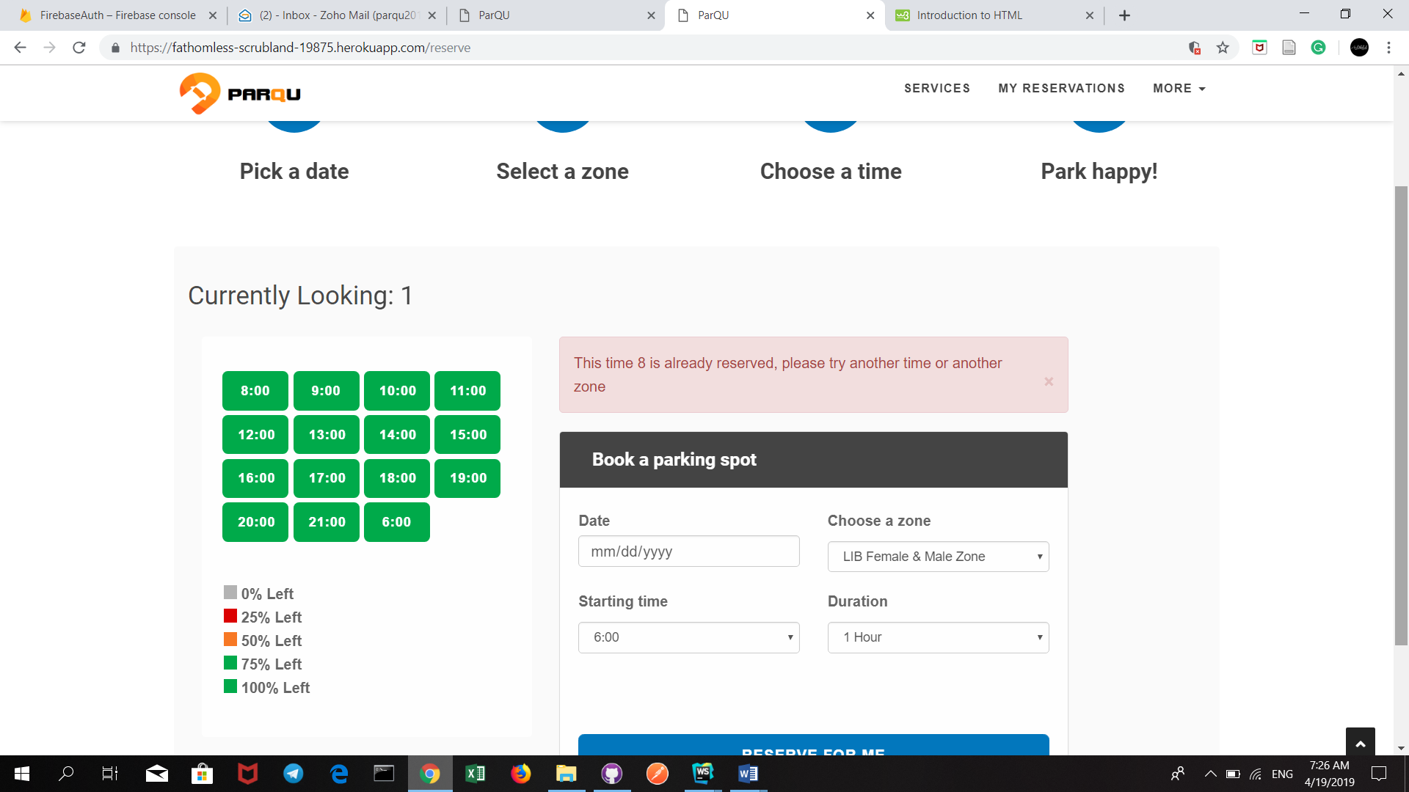

Reserve Parking 04

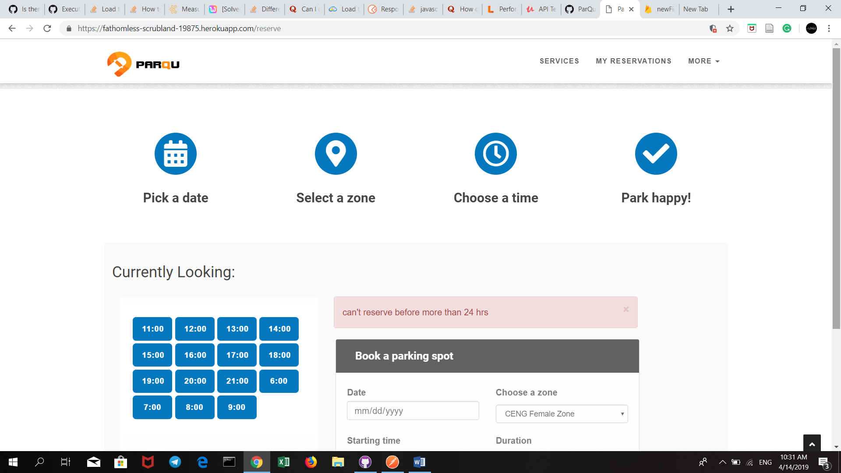

Reserve Parking 05

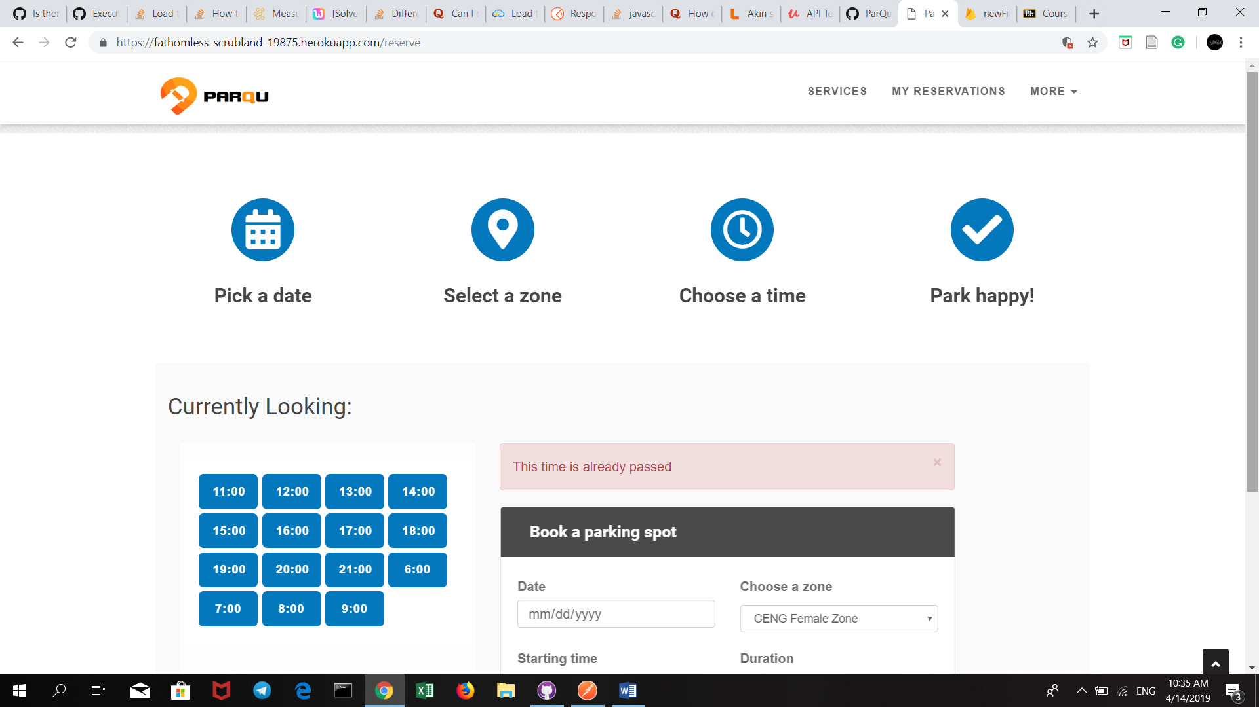

Reserve parking 06

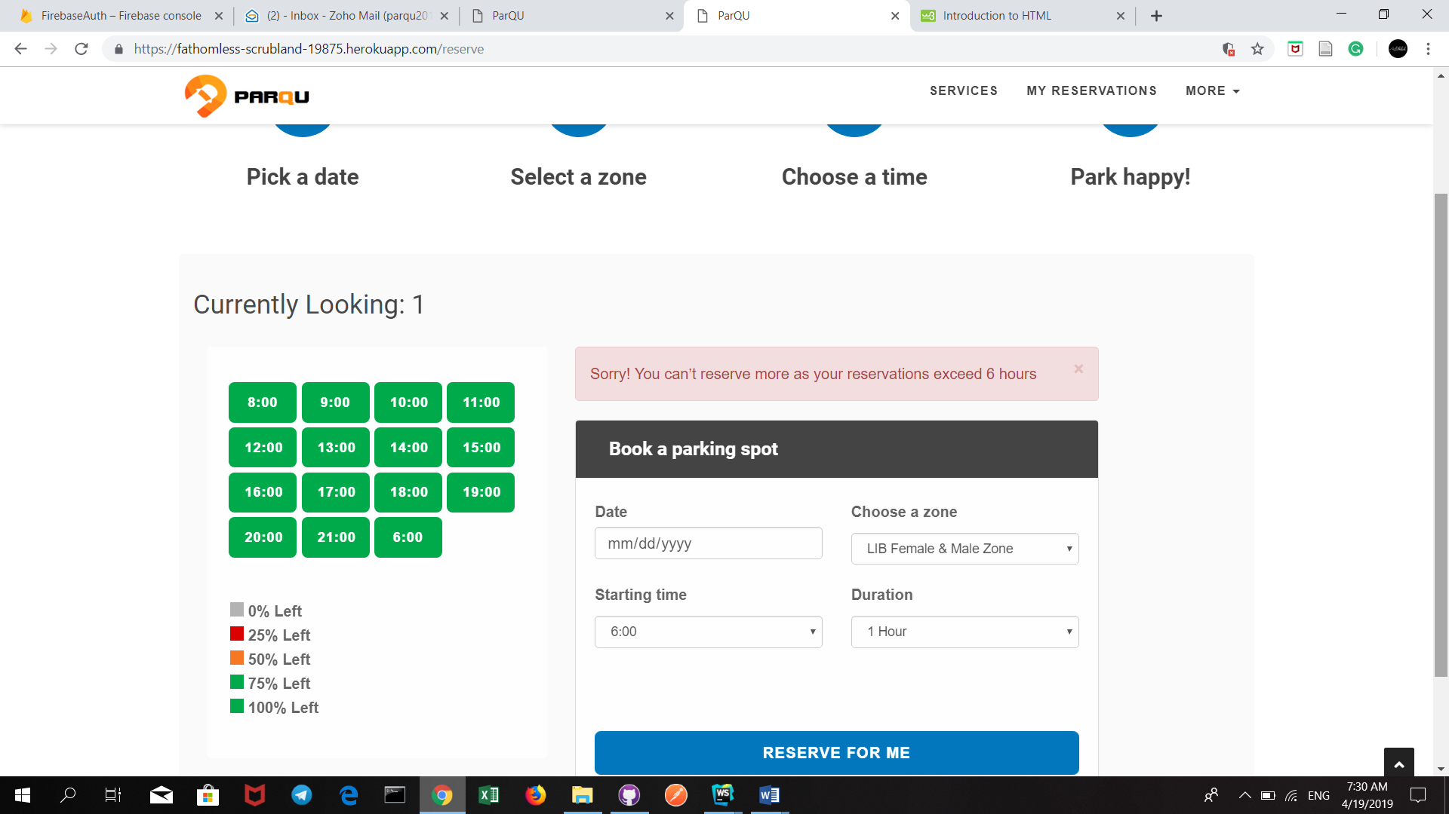

View Parking 02

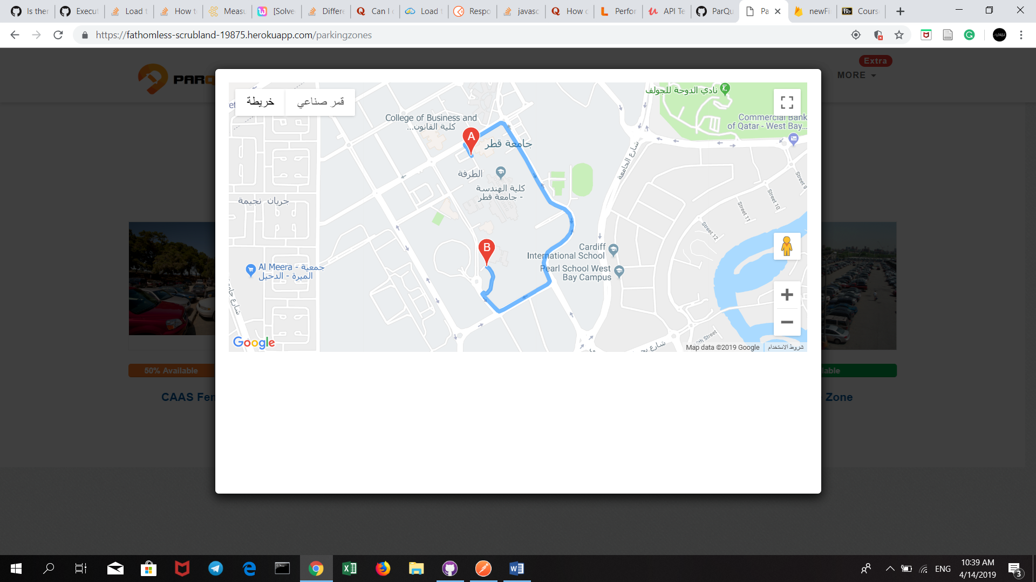

Cancel Reservation 01

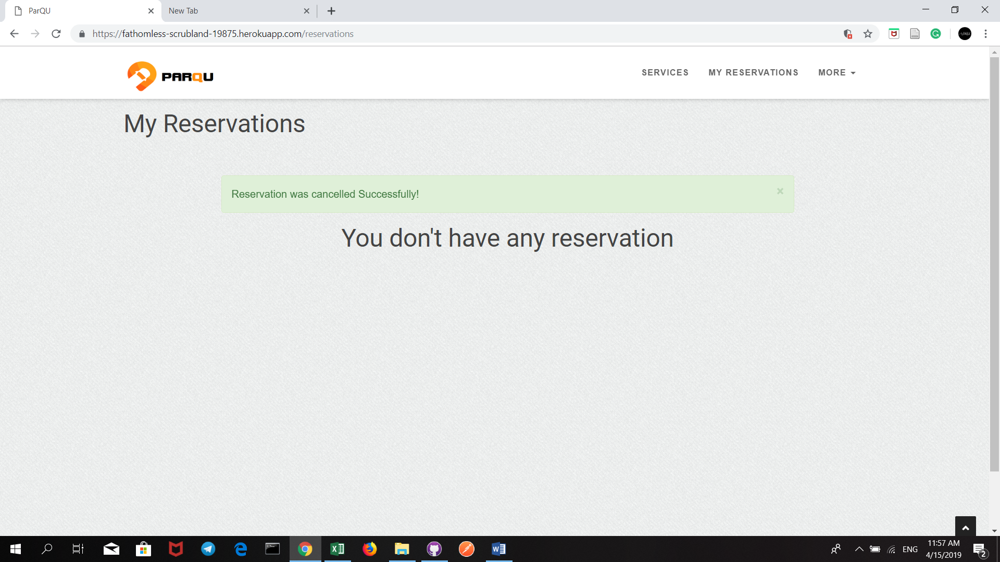

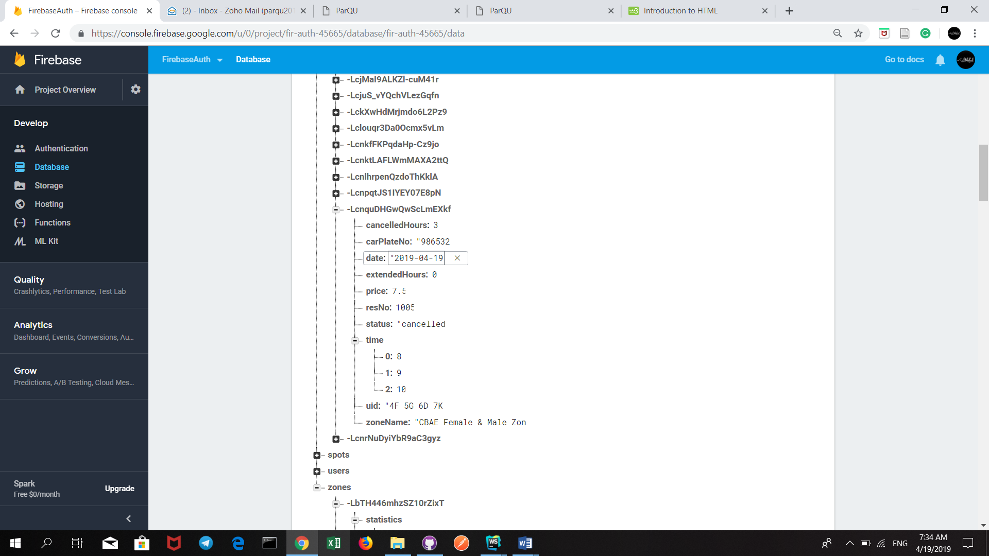

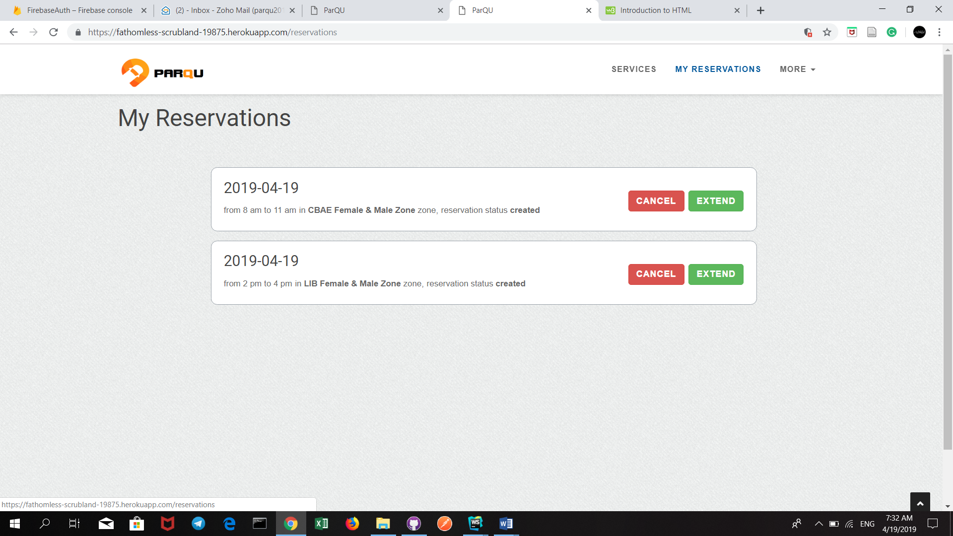

Extend Reservation 02

